(1)

% create array t

1. >> t = 32:3.6:93.2

Columns 1 through 11

32.0000 35.6000 39.2000 42.8000 46.4000 50.0000 53.6000 57.2000 60.8000 64.4000 68.0000

Columns 12 through 18

71.6000 75.2000 78.8000 82.4000 86.0000 89.6000 93.2000

1. % covert t to Fahrenheit

>> t = (t-32)*5/9

Columns 1 through 11

0 2.0000 4.0000 6.0000 8.0000 10.0000 12.0000 14.0000 16.0000 18.0000 20.0000

Columns 12 through 18

22.0000 24.0000 26.0000 28.0000 30.0000 32.0000 34.0000

1. % write the equation and plot

>> p = 5.5289*10^-8*t.^3 - 8.5016*10^-6*t.^2 + 6.5622*10^-5*t + 0.99987

plot(t,p)

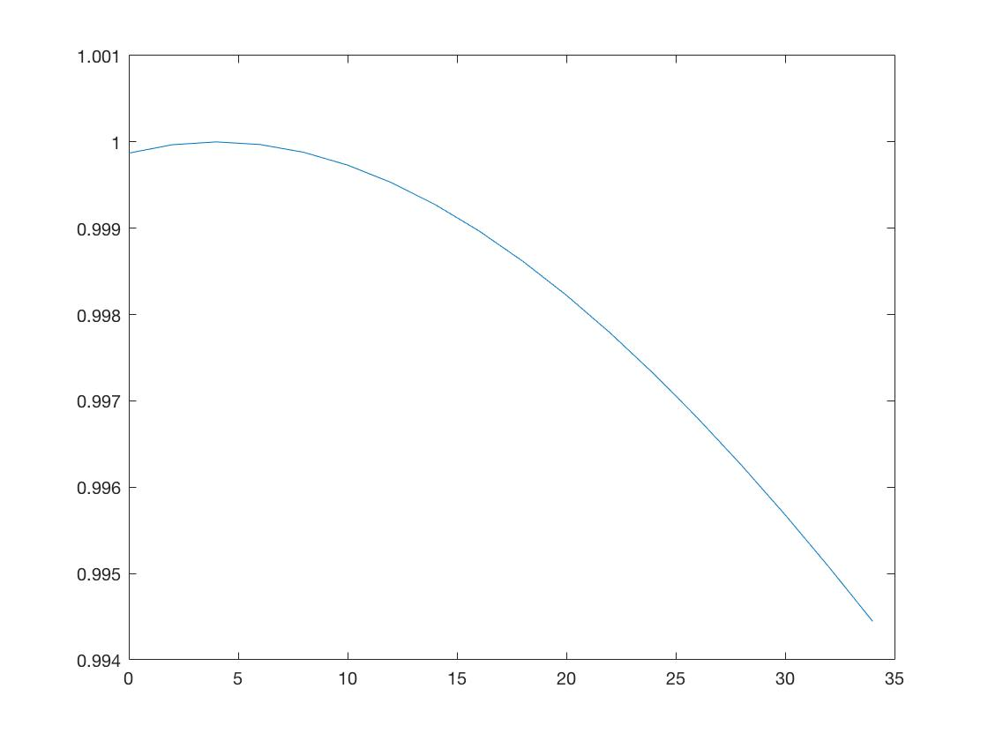

2. %create x on an interval of 0.1

>> x = 0:0.1:1.5*pi

>> plot(x,cos(x))

>> hold on

>> y = 1 - x.^2/factorial(2) + x.^4/factorial(4) - x.^6/factorial(6) + x.^8/factorial(8)

>> plot(x,y)

>> legend(‘cos’,’Mac’)

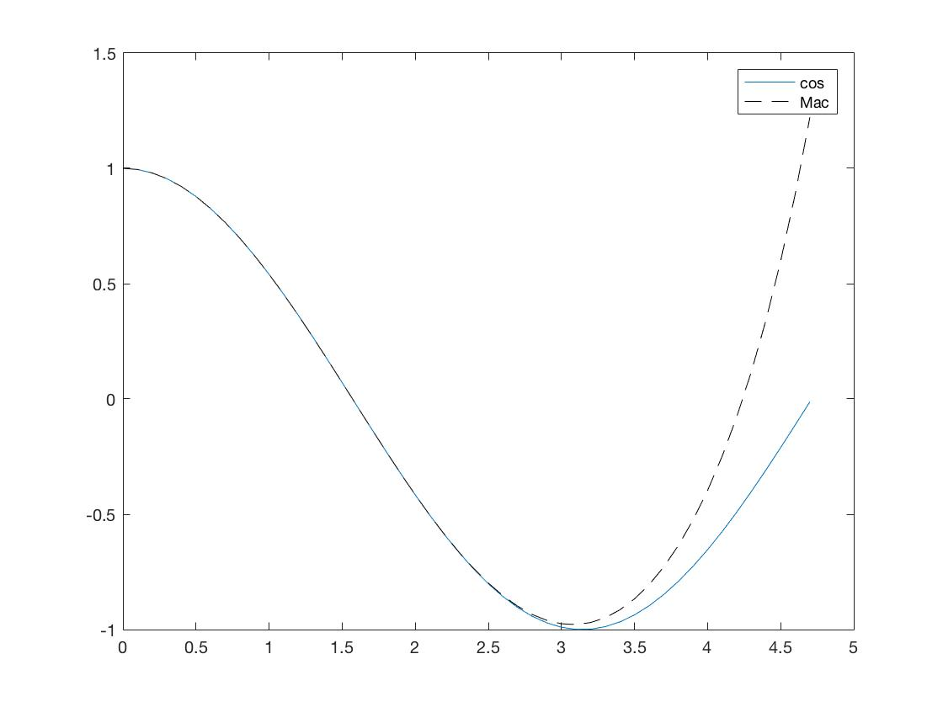

3.

%simply list each cases

function [r, theta] = coordinates(x, y)

%UNTITLED4 Summary of this function goes here

% Detailed explanation goes here

r = sqrt(x^2 + y^2)

if x > 0

theta = atan(y/x)

elseif x<0 & y>0

theta = atan(y/x)+pi

elseif x<0 & y<0

theta = atan(y/x)-pi

elseif x < 0 & y == 0

theta = pi

elseif x == 0 & x > 0

theta = pi/2

elseif x == 0 & x < 0

theta = -pi/2

else

theta = 0

end

theta = theta/pi*180

end

|  |  |  |  |
| --- | --- | --- | --- |
| x | y | r | theta |
| 2 | 0 | 2 | 0 |
| 2 | 1 | 2.2361 | 26.5651 |
| 0 | 3 | 3 | 0 |
| -3 | 1 | 3.1623 | 161.5651 |
| -2 | 0 | 2 | 180 |
| -1 | -2 | 2.2361 | -116.5651 |
| 0 | 0 | 0 | 0 |
| 0 | -2 | 2 | 0 |
| 2 | 2 | 2.8284 | 45 |

4.

% I used quiver3 function to make sure every vector originates from the origin

function c = abc(v1, v2)

mag1 = sqrt(sum(v1.*v1));

mag2 = sqrt(sum(v2.*v2));

d = dot(v1,v2);

degree = acosd(d/(mag1*mag2))

c = cross(v1,v2)

magc = sqrt(sum(c.*c))

end

a.

>> a = [6,4,2]

>> b = [2,6,4]

>> c = abc(a,b)

degree =

38.2132

magc =

34.6410

c =

4 -20 28

>> quiver3(0,0,0,6,4,2,'--')

>> hold on

>> quiver3(0,0,0,2,6,4,'--')

>> quiver3(0,0,0,4,-20,28)

>> legend('a','b','c')

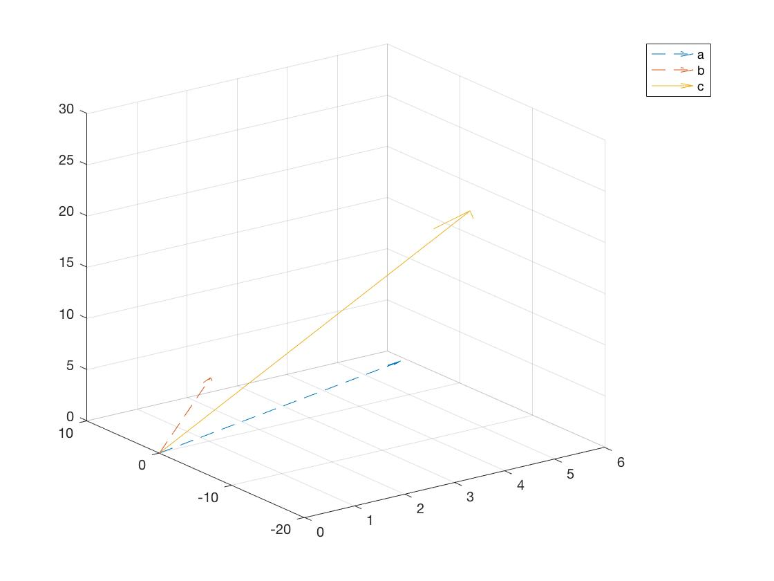

b.

>> a = [3 2 -6]

>> b = [4 -3 1]

>> c = abc(a,b)

degree =

90

magc =

35.6931

c =

-16 -27 -17

>> quiver3(0,0,0,3,2,-6,'--')

>> hold on

>> quiver3(0,0,0,4,-3,1,'--')

>> quiver3(0,0,0,-16,-27,-17)

>> legend('a','b','c')

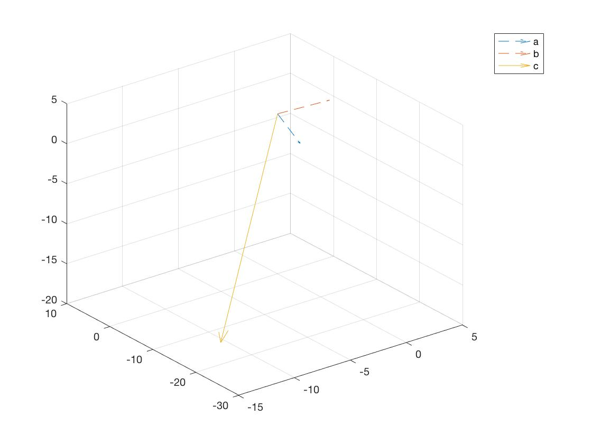

c.

>> a = [2 -2 1];

>> b = [4 -3 1];

>> c =abc(a,b)

degree =

11.3099

c =

1 2 2

magc =

3

>> quiver3(0,0,0,2,-2,1,'--')

>> hold on

>> quiver3(0,0,0,4,-3,1,'--')

>> quiver3(0,0,0,1,2,2)

>> legend('a','b','c')

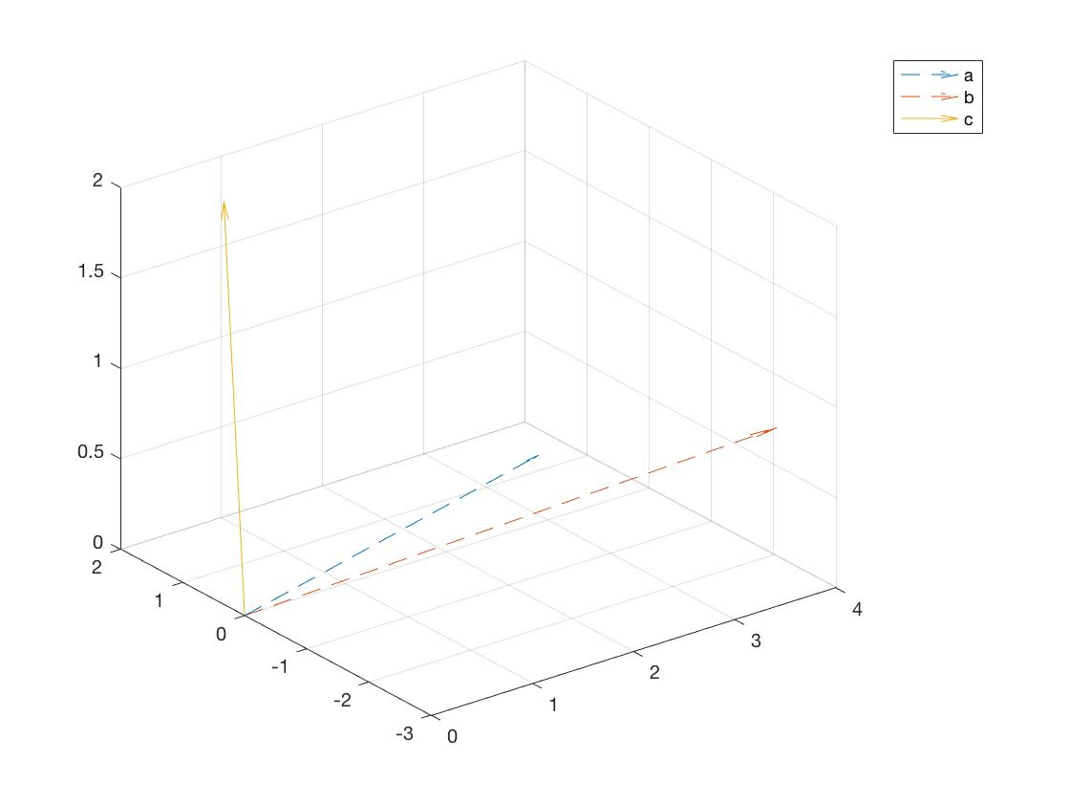

d.

>> a = [-1 0 0]

>> b = [0 -1 0]

>> c = abc (a,b)

degree =

90

c =

0 0 1

magc =

1

>> quiver3(0,0,0,-1,0,0,'--')

>> hold on

>> quiver3(0,0,0,0,-1,0,'--')

>> quiver3(0,0,0,0,0,1)

>> legend('a','b','c')

